QTP

QTP/UFT: full form is quick test professional. Also known as unified functional testing. It is a licensed tool. It is used to capture environment, attributes of the application in form of recording and it must have ability to run (environment) the application under test.

Attributes of QTP

* It is an icon-based tool that automates the regression and Functional Testing of an application
* Both technical, as well as a non-technical tester, can use Micro Focus QTP
* It provides both features- Record as well as Playback
* We can test Desktop as well as the Web-based application
* QTP Testing is based on scripting language VB script. easy language is used understanding the requirement of tester.

Selenium: competitor of QTP OR UFT in market and mostly used tool because of its some advantages to the companies. Which are listed here

* It is free and open source
* Different languages like java , c#, .NET can be used
* It has scripting and record as a separate tool that is called selenium ide and web driver.

Terminologies of automation tools

Synchronization point: Synchronization point is the time interface between Tool and Application under the test that we are testing right now. Synchronization point is to add wait time to let our script know to wait to other action to happen.

In other words, wait time event is inserted between elements to let each element perform their actions before continuing next action.

Parameterization: when we have same steps in all test cases except data that is passed to check pass or fail status of script or test case.

Parameterization is used to run same script for passing Mutiple set of data to find their respective status pass or fail.

Checkpoint: it is used in automation testing to check whether actual and expected result is same or not and making sure if the required status pass, fail or done is showing up.

Practical implementation of QTP

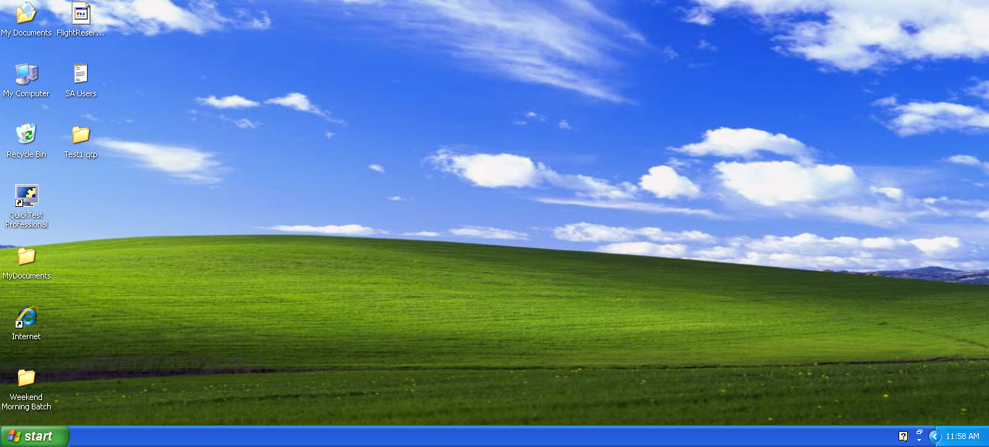

Checking the things that we needed to trace the environment I.e language use , window or webbased application etc of application under test

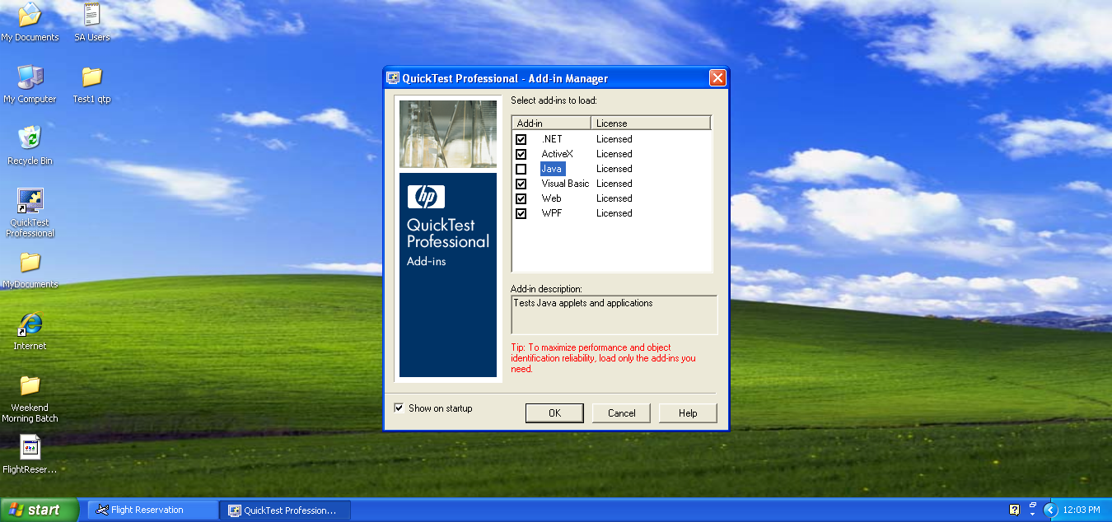

Application that will be tested in this module which is developed in .net

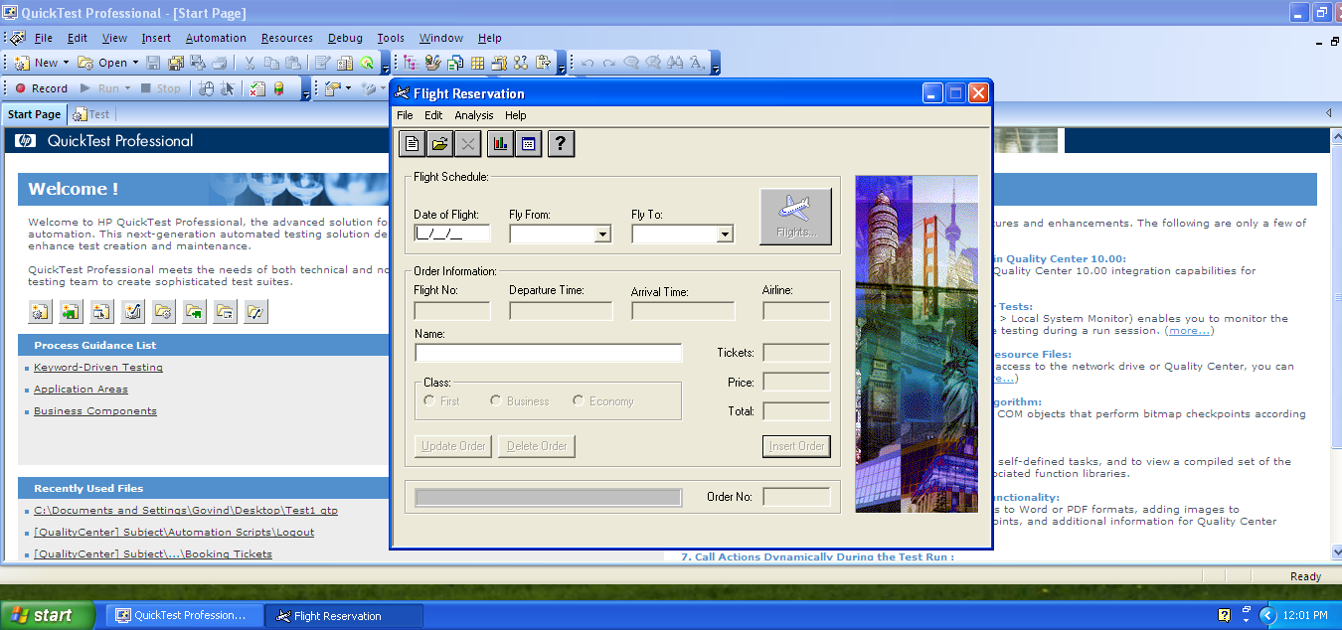

Going through basic features of QTP/UFT

Record and play feature that make job of manual tester easy by recording and playing .

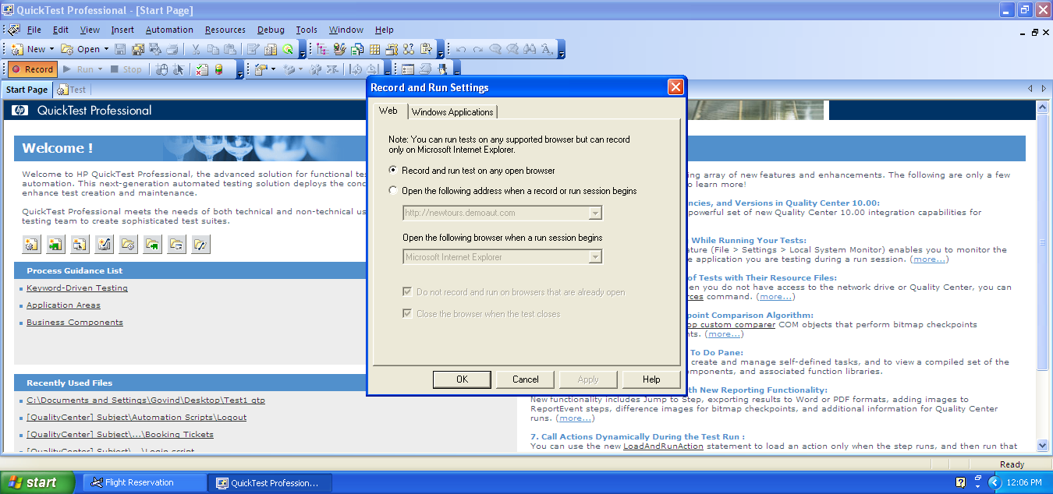

Recorded the flight reservation window in recording mode and application was set to its original state after inserting order to run the script next time .

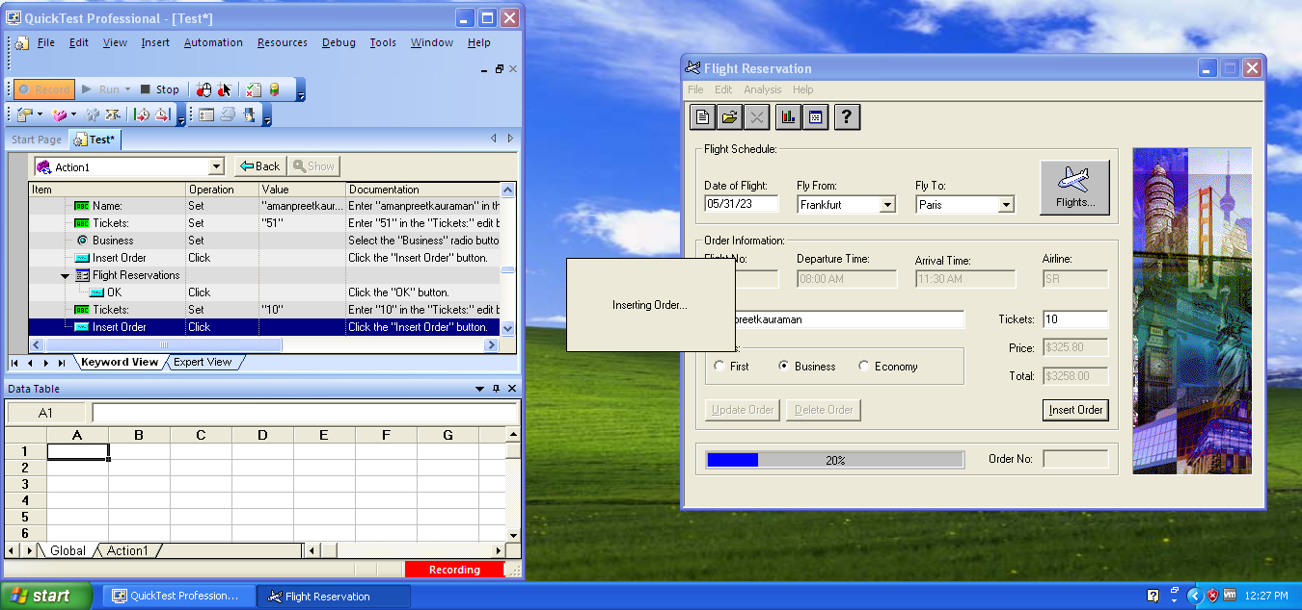

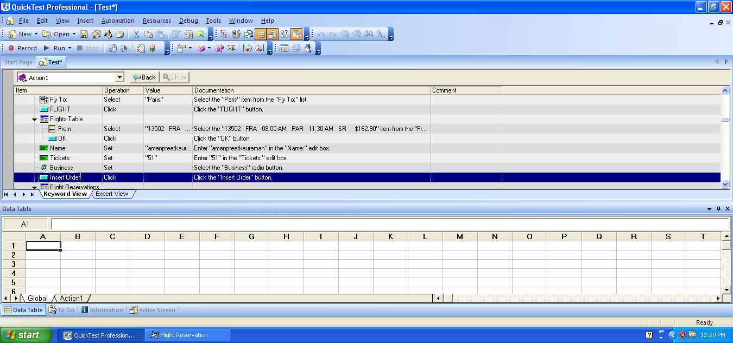

2 views our available in QTP

Keyword: meant for manual users with no language knowledge or little knowledge and more user friendly.

All of our recording comes in ACTION

Elements or Objects and their respective actions like click, select, check etc.even steps are auto generated in this step for manual testing.

Expert view: is more with language view to see defects and find issue.

Object Repository: is a brain of QTP where all the recorded steps are stored for future references or to recall the objects in future play of recordings.

Can we have accessed from Resouces: object repository

Not only actions of objects are recorded even their properties are also recorded in QTP. if any of the element is not recorded then no action can be performed on that object in future play.

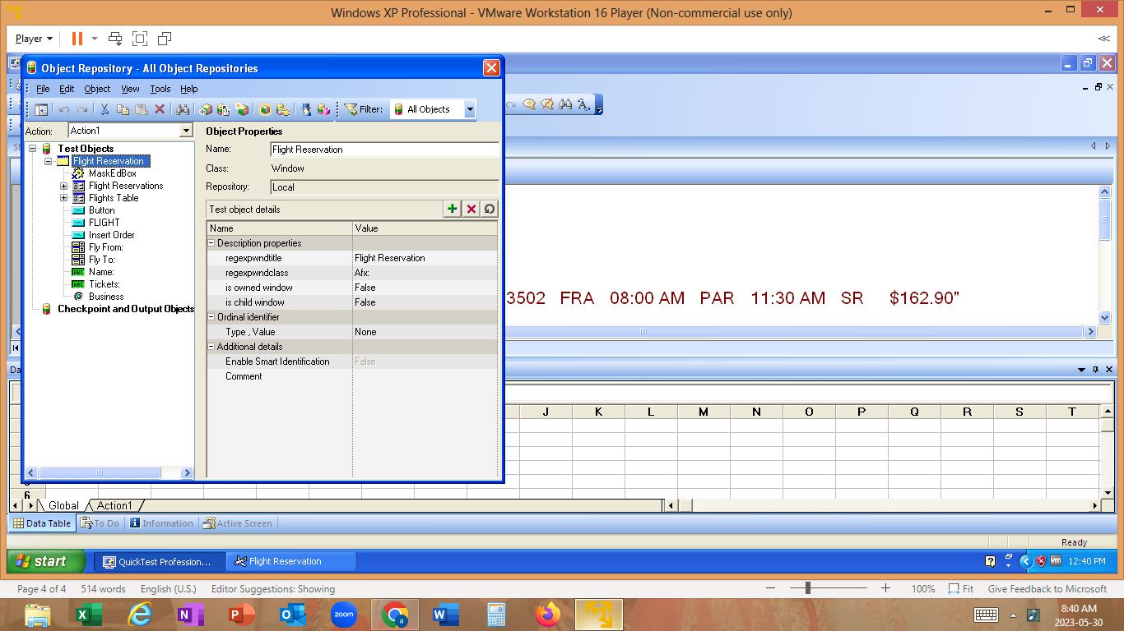



Object Spy: if I need to see properties of any element then this feature can we used all properties given by developer. will check properties of fly to win combo box down

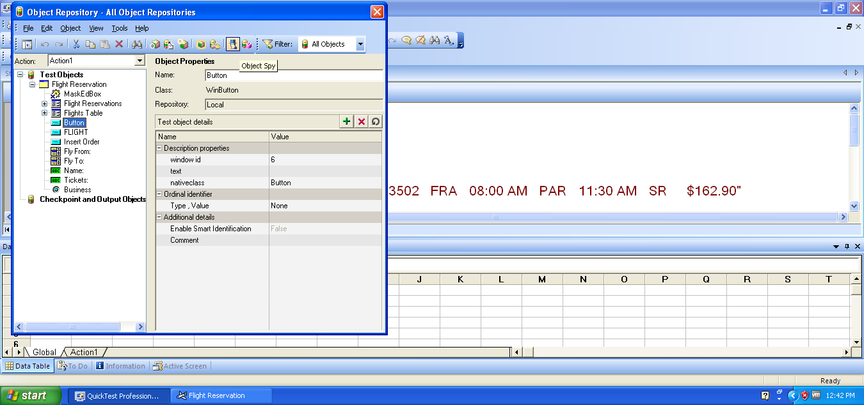

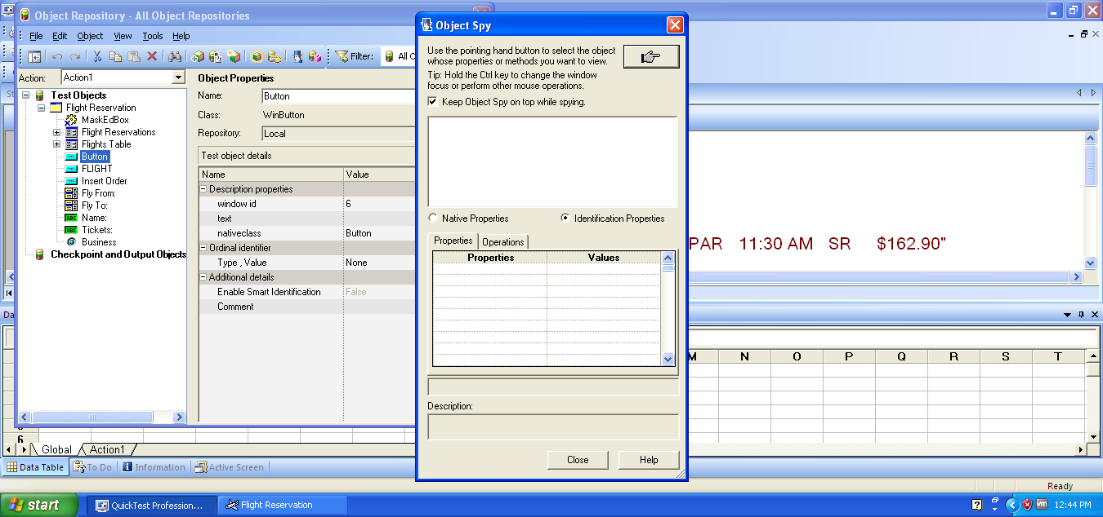

Locate in repository: total was not recorded so will check that

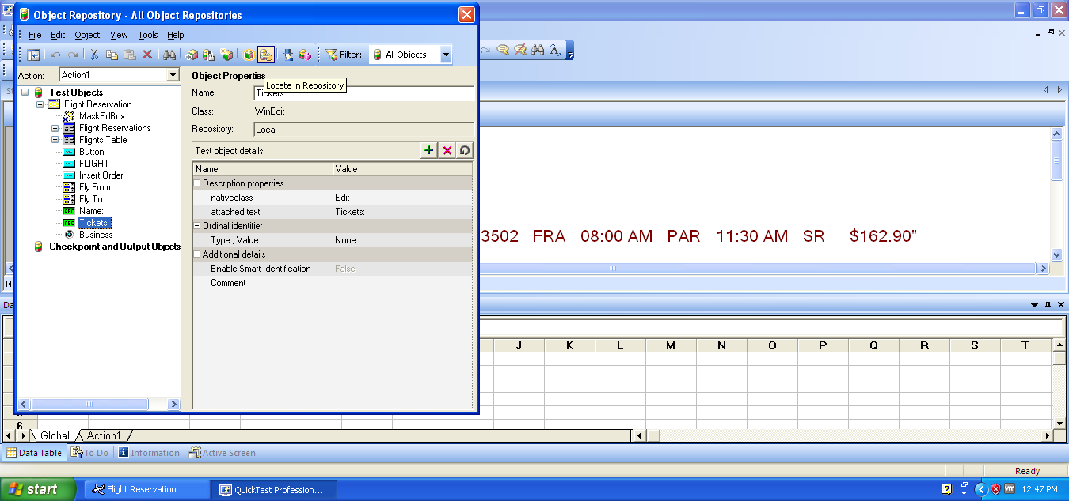

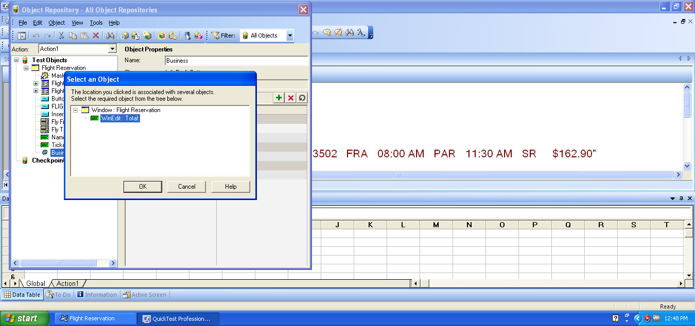

Highlight in application: to highlight elements in application in some situation we will highlight fly from

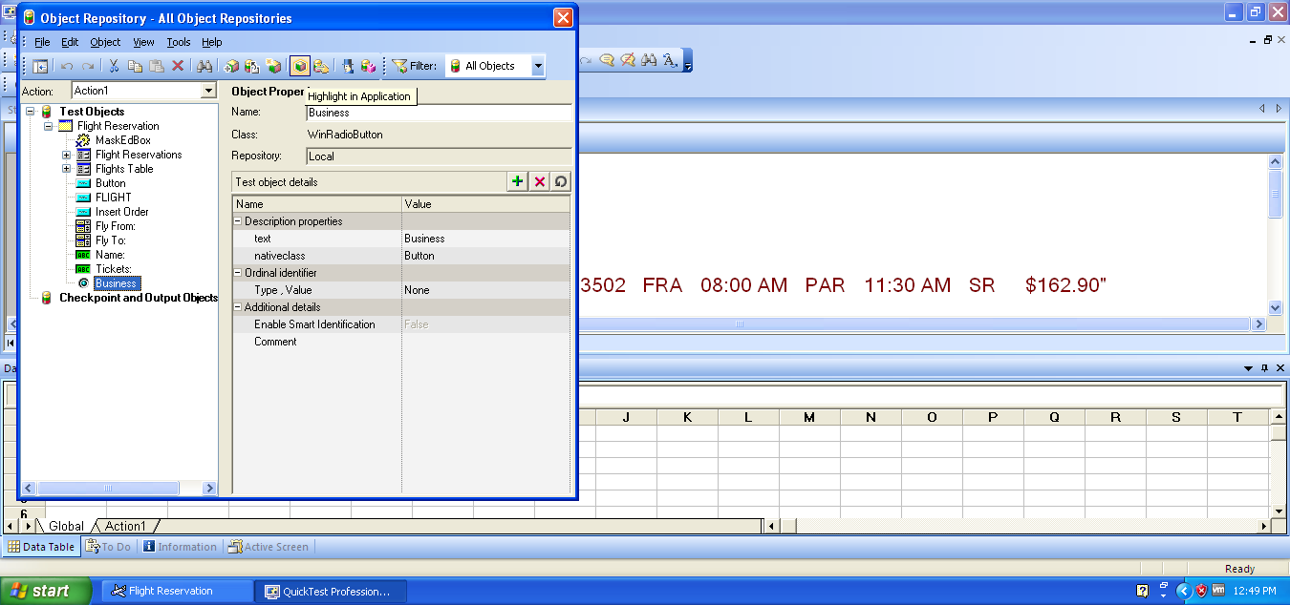

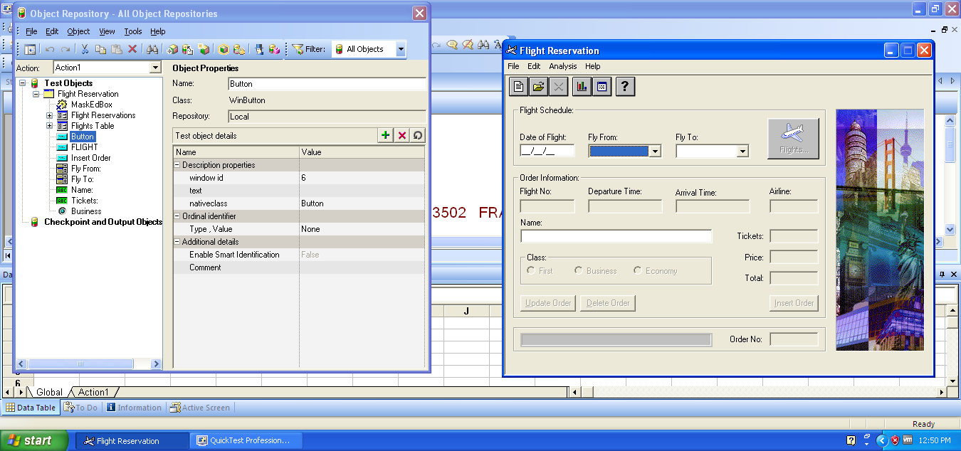

Add object to total: choose parent then click add object then select any object that is not in our list to add it in our repository but make sure parent is selected

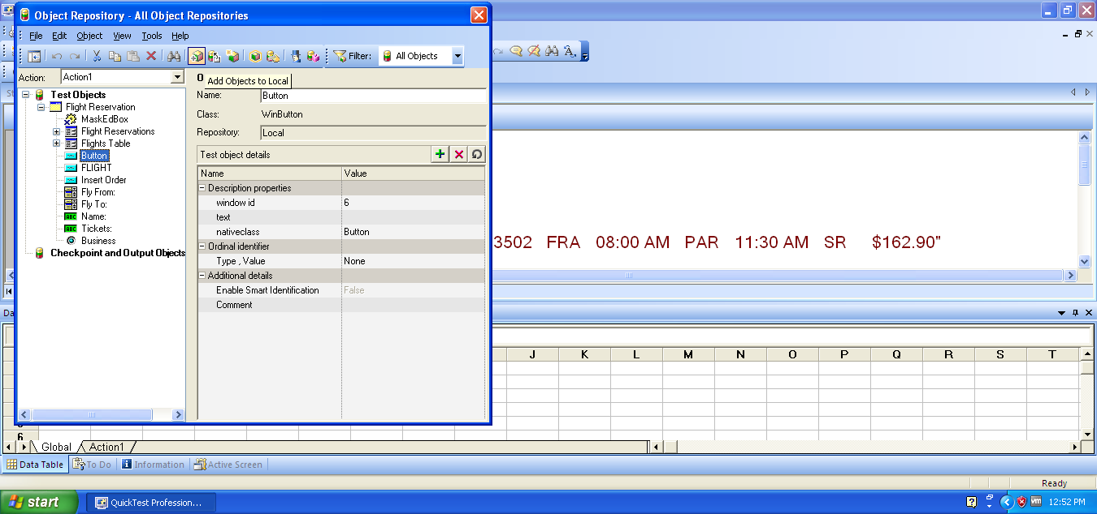

Define new test object: select parent and click define new if our application is not local

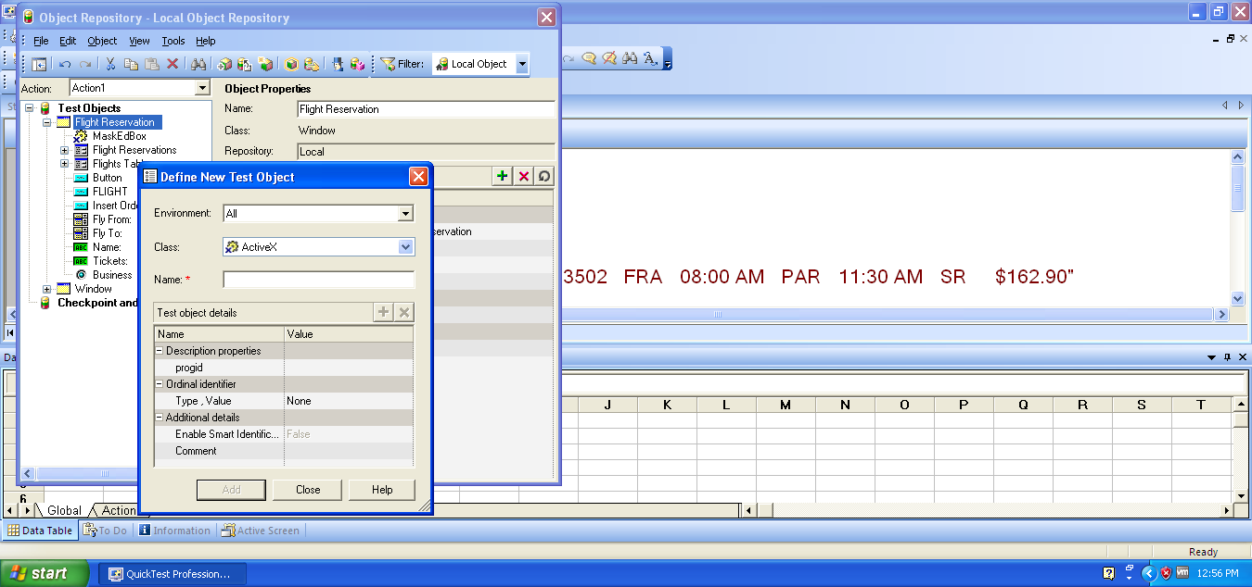

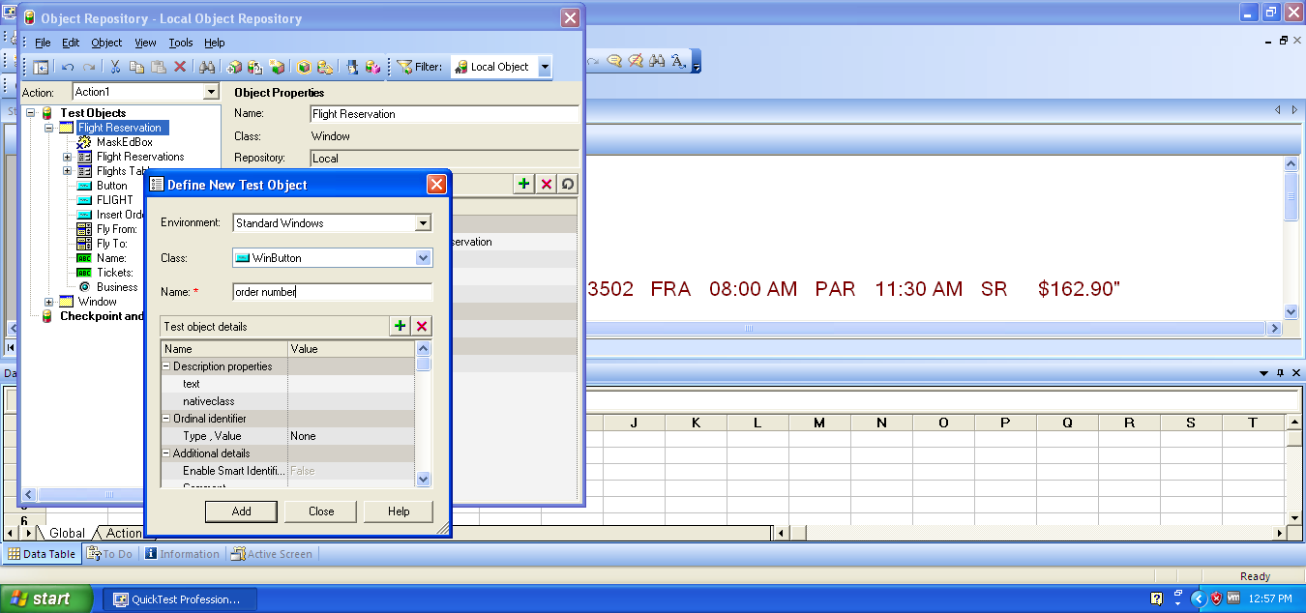

Find and replace: when client changes the requirement and we have lot of data to be changed with same minor change in all of them needed then this feature could be used.

Change one time it will be done automatically

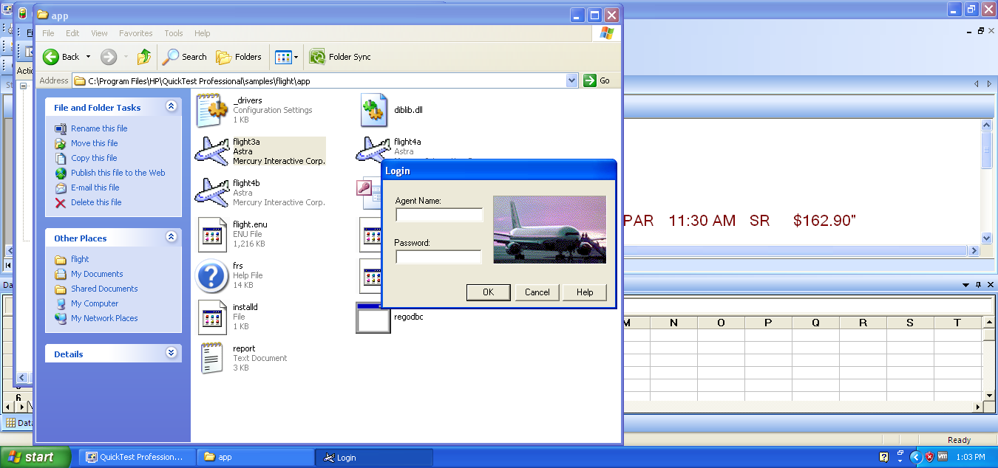

Where customer name is changed and it is failed because of element is not in the repository because element has been changed.

C:\Program Files\HP\QuickTest Professional\samples\flight\app\flight3

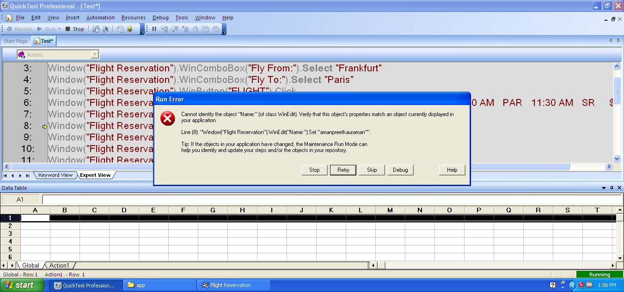

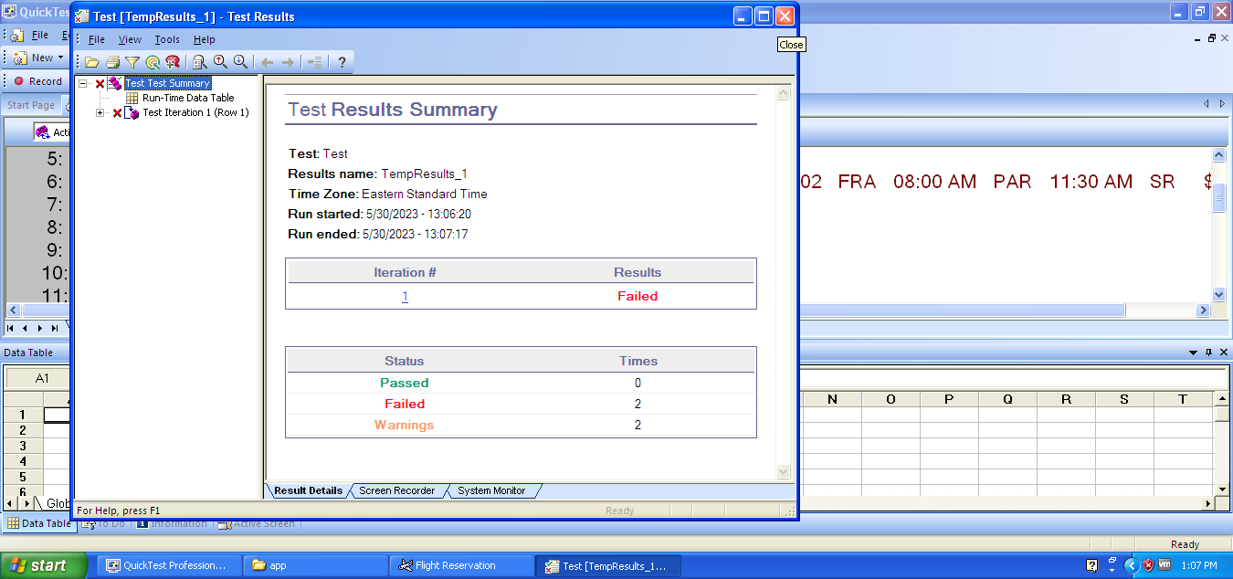

Synchronization: QTP by default time is 20 second and here to practice will change this time to see how wait event will affect the run of script. Script with 3 seconds recorrded and will run it and will see what error comes

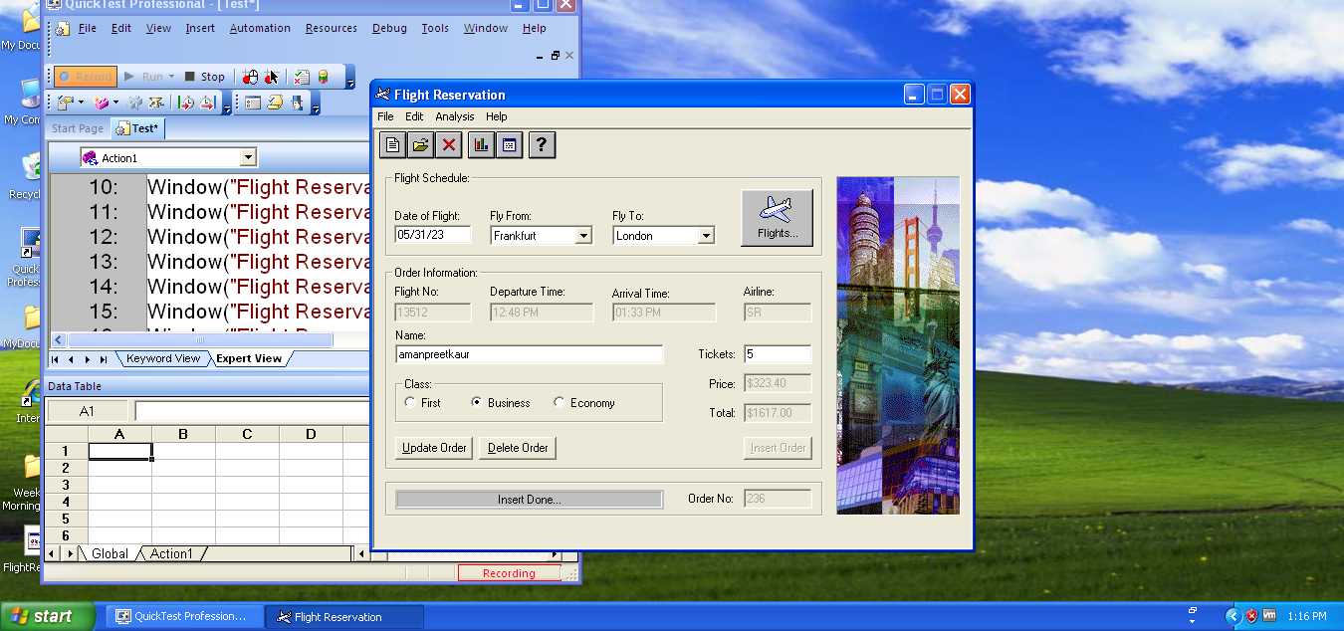

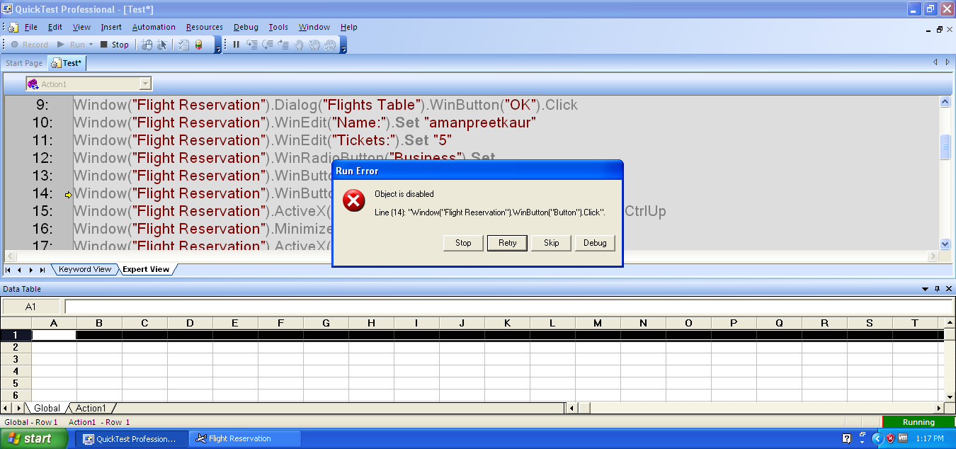

Object is disabled error because it did not had time to complete the steps

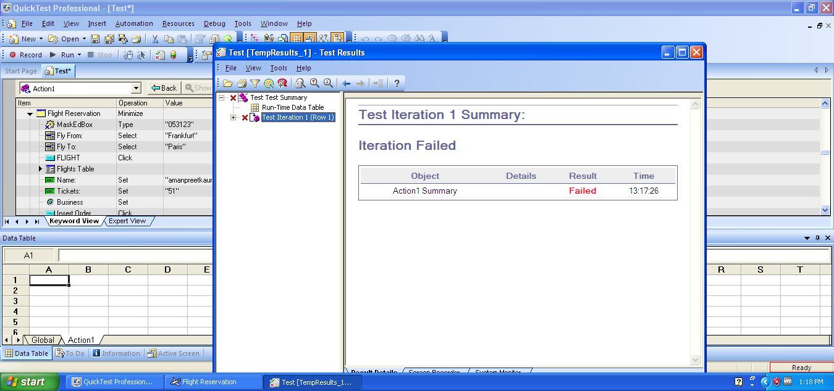

Now extra time will be given to perform this action and to perform synchronization

1)should click on object

2)on recording mode

3)insert synchronization point to run the script on time

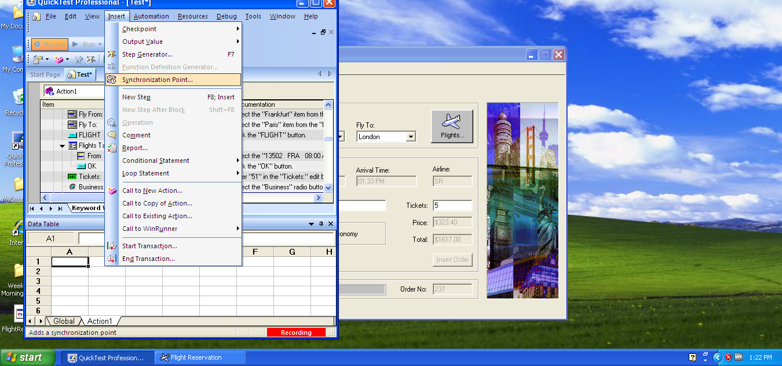

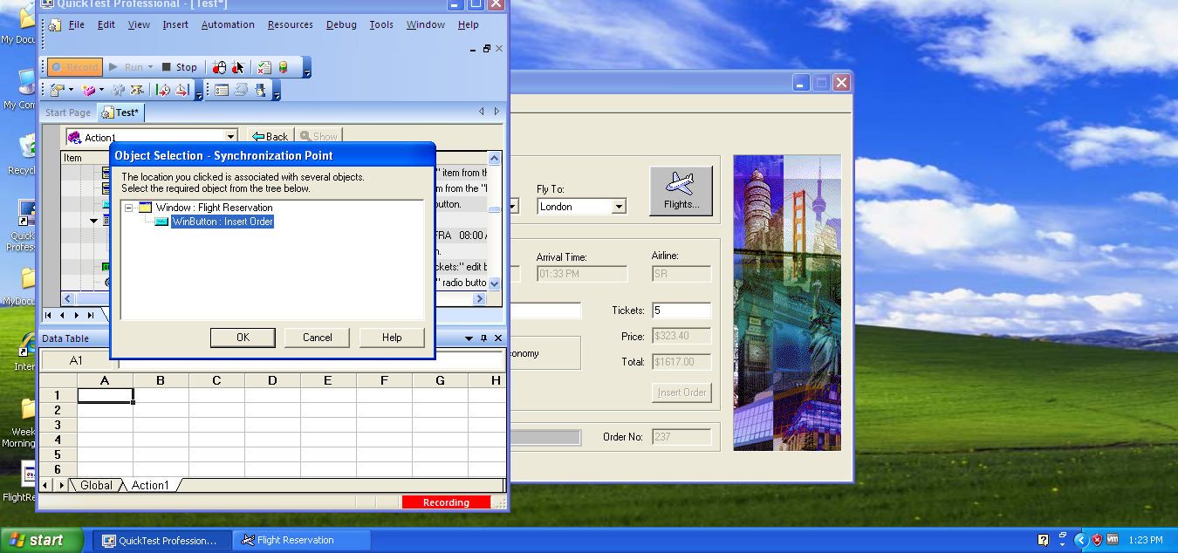

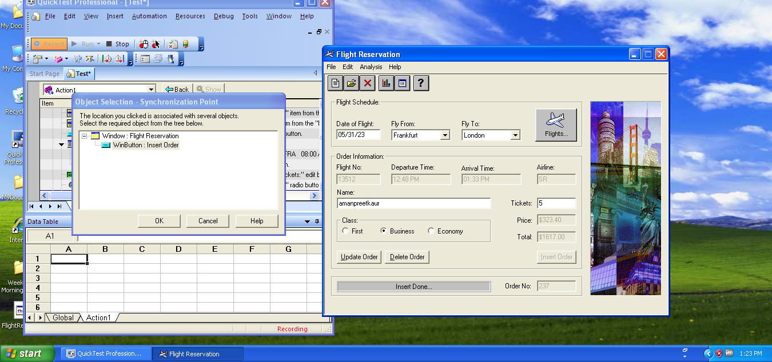

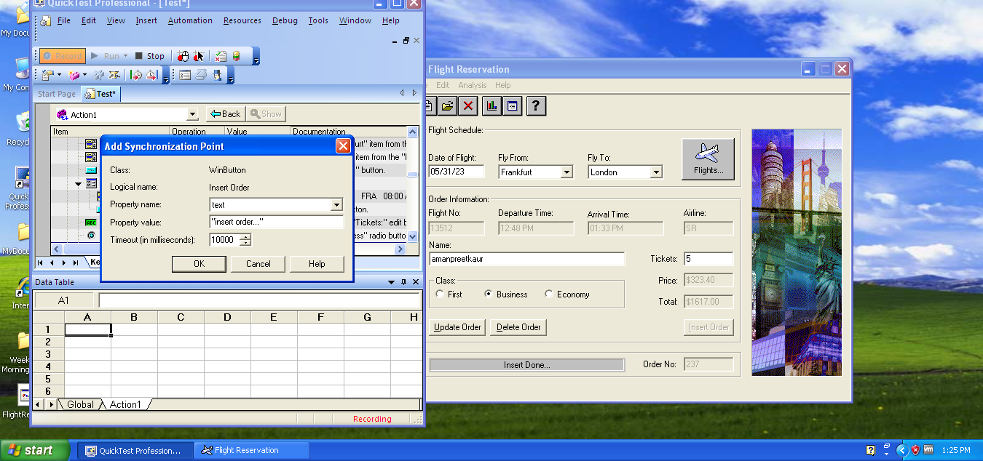

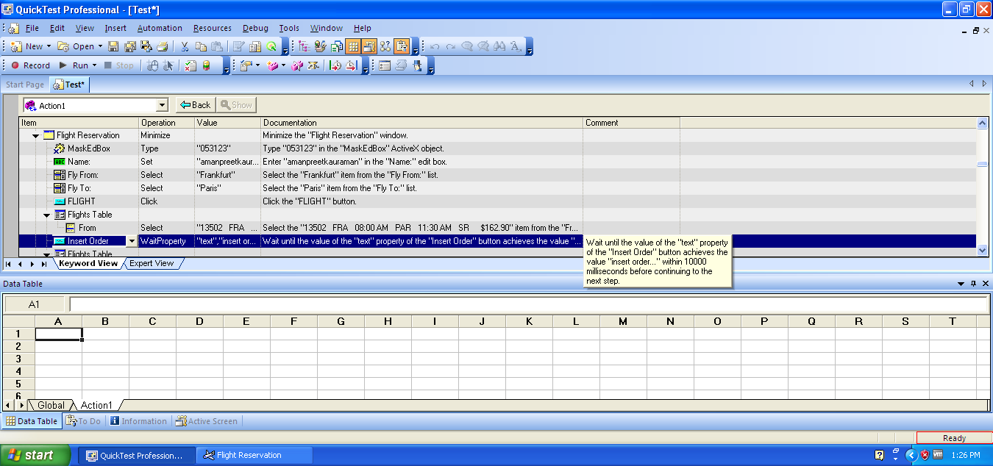

Wait property has been added to this particular object to rum script smoothly

Parameterization or data driven testing:

New script recorded to perform Mutiple set of data in same script

Means changing our value from constant value to pameterization means changing our data frequently in same script

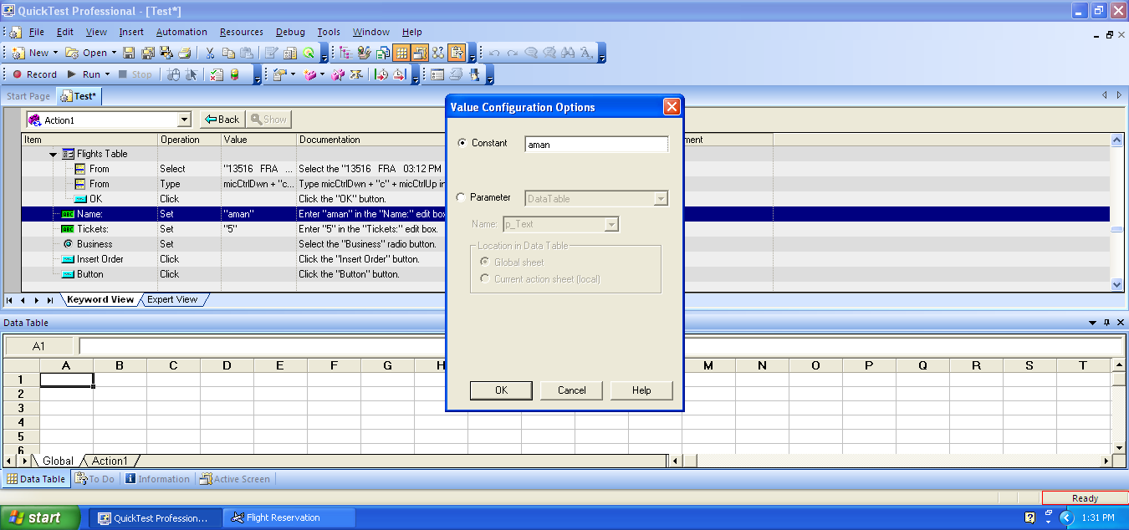

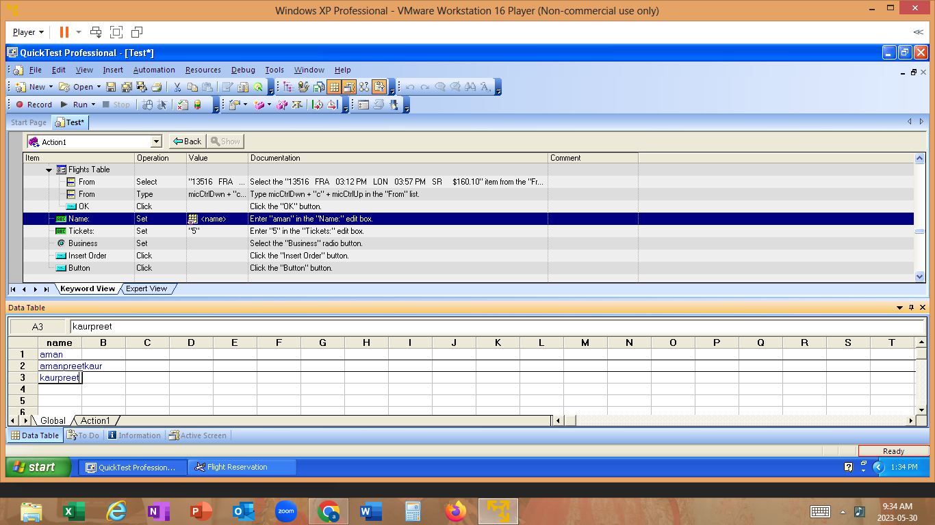

Passing 3 set of data for same field with 3 cycles its all done in this same field with only one run

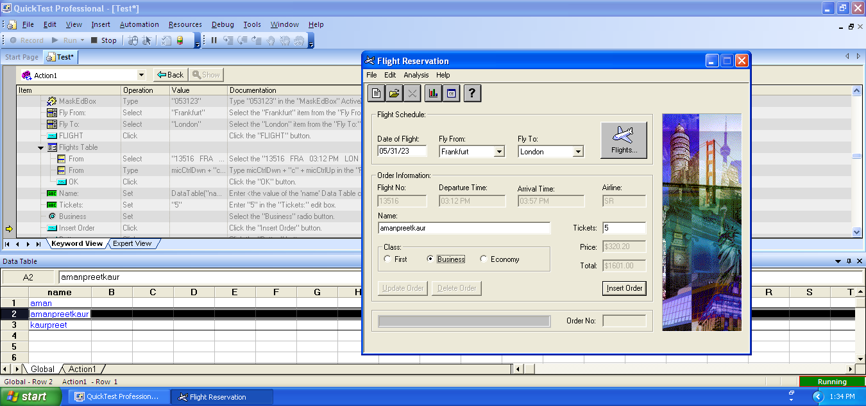

Reports for 3 cycles of script with results

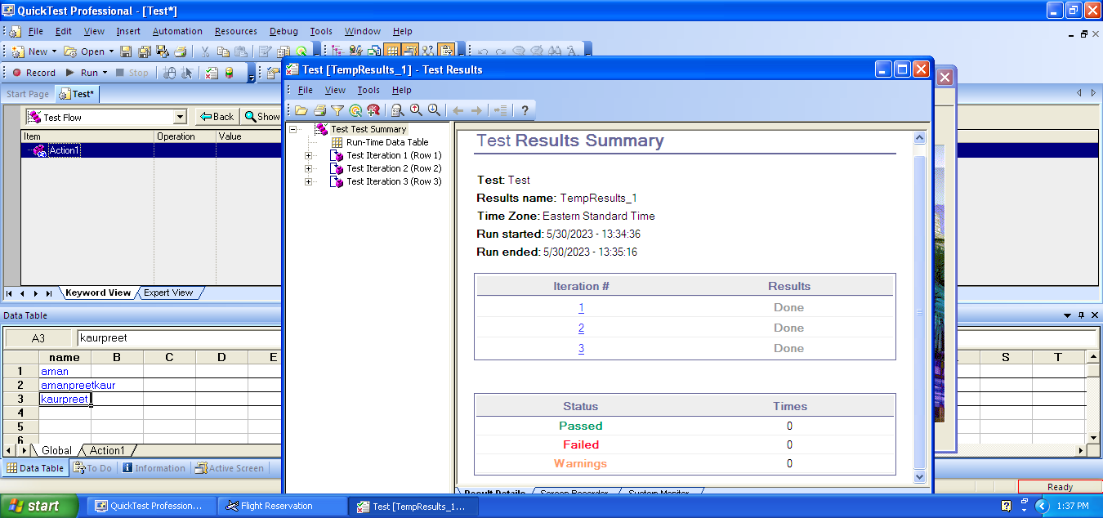

Checkpoints: used to check if required message or value is popping up according to requirement to say if actual or expected is same. Application and recording mode should be one .it is specific to the properties .

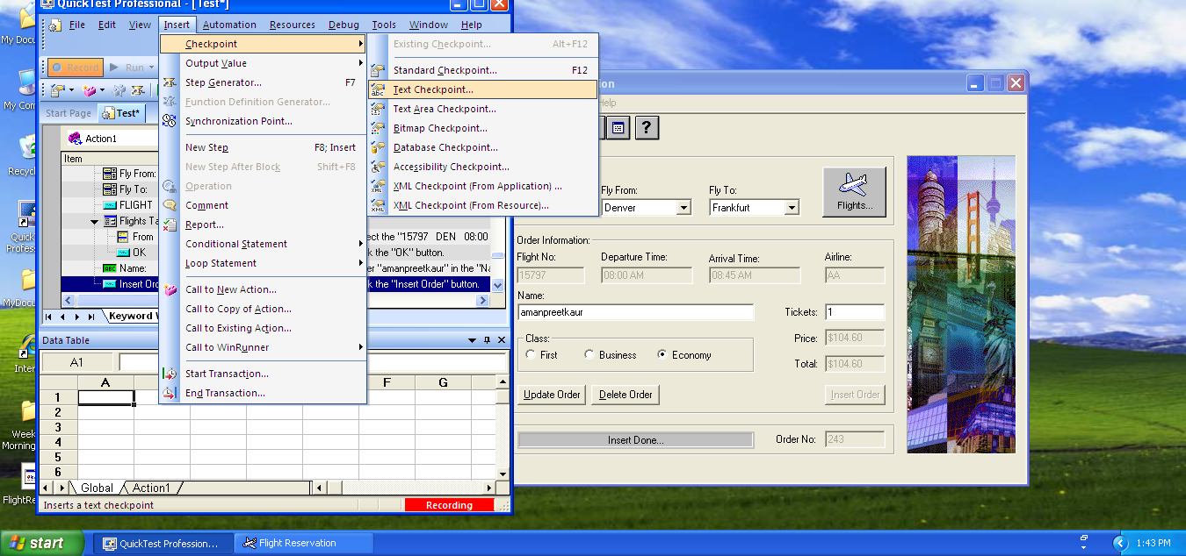



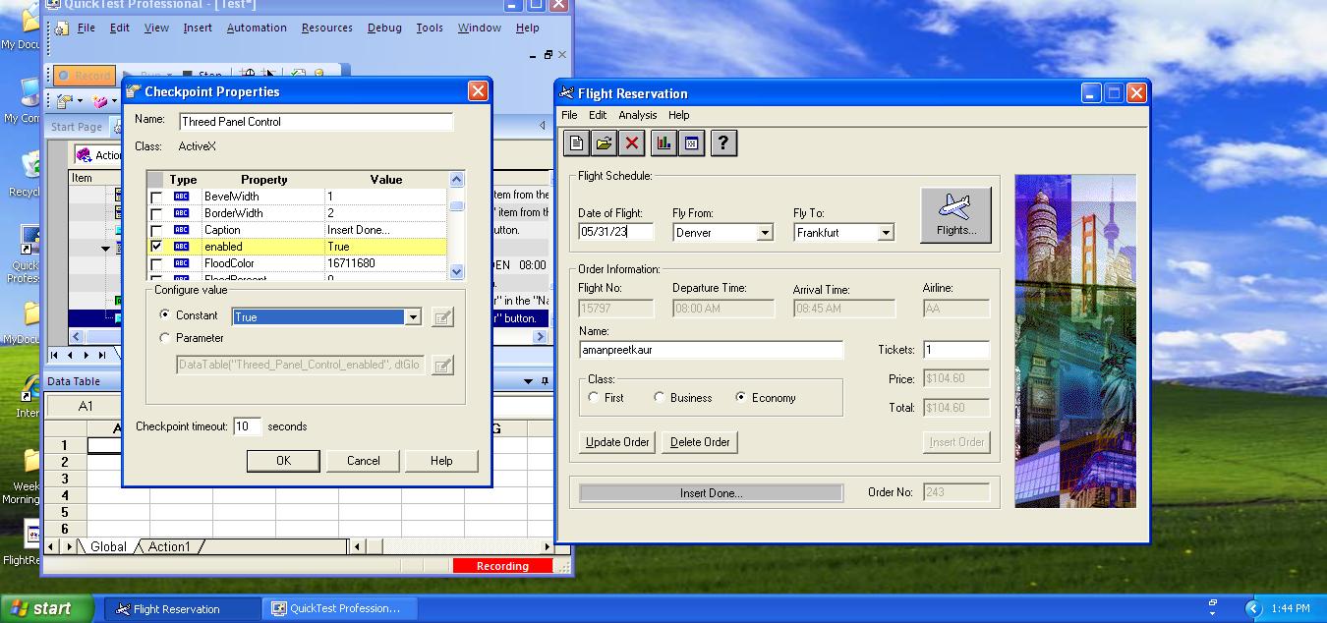

Will select only text property to see if it is according to requirement.

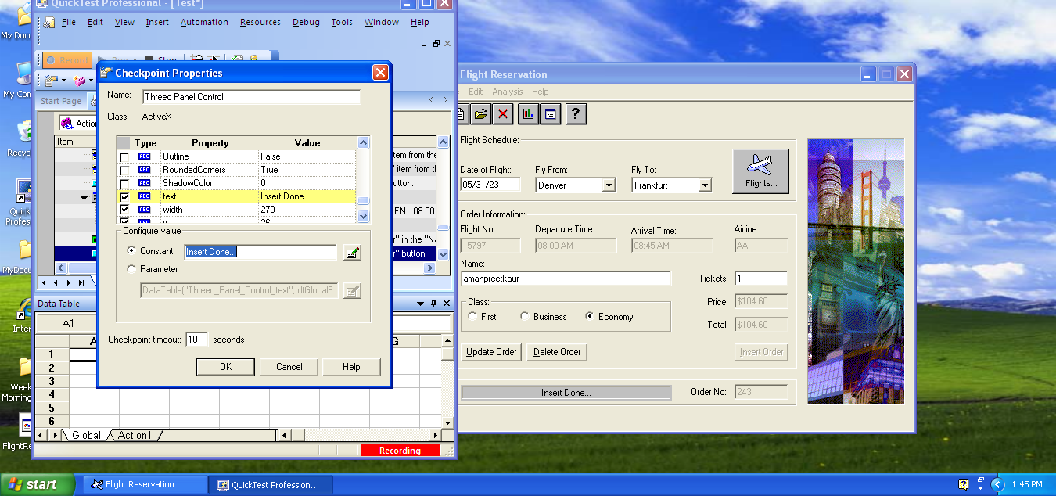

Staus is changed from done to passed because we specifically added checkpoints to make sure this step.